
ENROLLING NOW & OPEN
TO ALL MAJORS!!

STUDENT STUDY ABROAD
PROGRAM

BELIZE,
CENTRAL AMERICA

DECEMBER 28, 2015-JANUARY 11, 2016

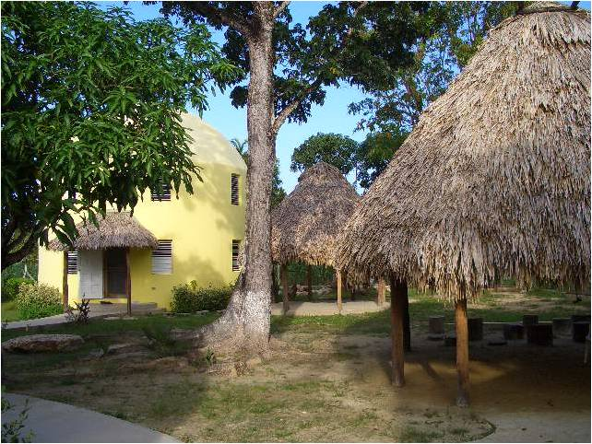
You will:

*Volunteer and Tutor in an
Orphanage and an Island School
*Stay several days on an Island,
Caye Caulker
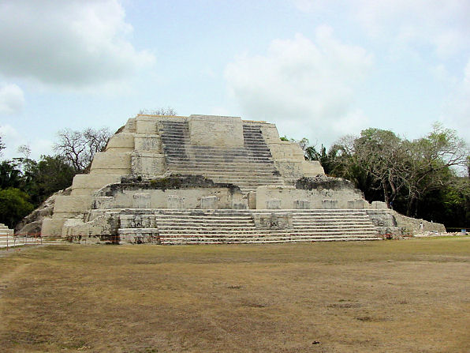
* See a Mayan
Temple!

LIMITED ENROLLMENT 4
SEATS LEFT IN THE PROGRAM!
“WTE Scholarships Available $700 - $1,000, Program and
Scholarship information at: www.studioabroad.com”.

FOR MORE INFORMATION CONTACT:
DR. JUDITH McCONNELL-FARMER, PROGRAM DIRECTOR
DEPARTMENT OF EDUCATION judy.mcconnell-farmer@washburn.edu

