DEPOSIT PROCEDURE
Type in my.washburn.edu in the address field
Sign In
University Services Tab
Quick Links – Departments
Finance Office
Forms
Business Office
Deposit Form (Excel Document)

Complete a Deposit Form found under

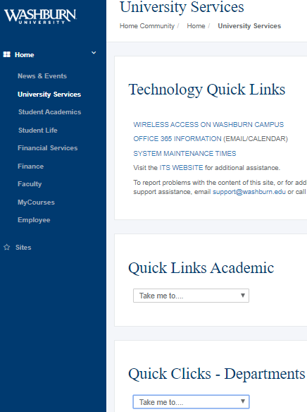

Click on Forms

Scroll down to Business Office
Open the excel document “Deposit Form”

Read the required information highlighted in yellow. Complete the contact information and Deposit Information.

The “Banner Description” is the reason for the deposit; example – Memberships (30 characters max)
Abbreviate description if necessary, do not take to next line.

Agency Fund is 800000, no ORGN code, ACCT - 29xxxx, no PROG, no ACT or no LOCN.

Sales Tax needs calculated for all goods or services sold. The sales tax calculator form is under “Tax Matters” section of the Finance forms. Donations are not subject to sales tax.

List checks with payee name, check number & dollar amount in the comments section, or attach an excel spread sheet with this information. DO NOT copy checks.

If reimbursement is for an expense account (7xxxxx), please provide name of payee and WU invoice number (I03xxxxx) in the Banner Description. This information is so the deposit can be cross referenced with the invoice paid within a budget query. Call the Finance Office (ext. 2031) with questions how to get these numbers.

Take the completed deposit form and one copy, with cash/checks/credit card #, money order/ to the Business Office cashiers, Morgan Hall, room 103-O. (deposits DO NOT include Bod Bucks)

Note: Total Deposit Information must equal Total FOAPAL Information.

